**The Impact of Rising Costs of Living on Economic Health in Africa (2016 – 2021)**

**In recent years, many African countries have seen an astronomical rise in cost of living. For this analysis, I chose to understand how rising living costs have impacted the economic health of member nations. The analysis was streamlined from 2016 to 2021 for two reasons:**

1. **From 2015 to 2017, oil prices soared in Nigeria, Angola, and South Africa leading to the devaluation of currencies. Also, countries like Zimbabwe, and The Zambia experienced extremely high inflation that affected many households. This was closely followed by the 2020 COVID19 pandemic which caused an increase in food prices. It is thus important to examine how these factors impacted the economy.**
2. **Most dataset outside of this year range had missing values, so it was important to focus on a specific time period for a comprehensive insight.**

**Examining the inflation, unemployment, cost of living, and low GDP annual growth metrics**

1. **Inflation**

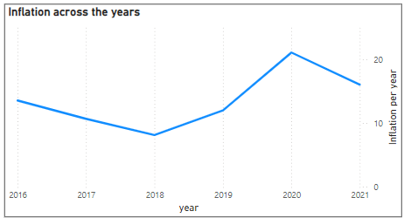**This graph is a high-level overview of the fluctuations in inflation level across the years. Worthy of note is that the continent experienced the highest inflation rate in 2020. Apparently, the pandemic distorted economic activities in many African countries.**

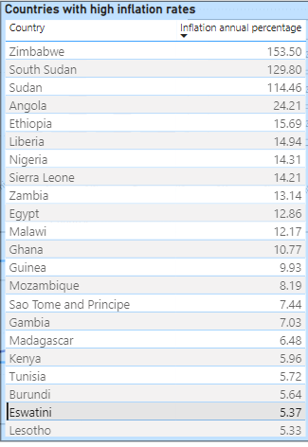**Inflation is interpreted as the increase in the prices of good over a period. It is a measure of the economic vibrancy of a nation. If a country has an inflation rate greater than 2 - 4 %, it is considered to be at risk of a financial crisis. In this table, Zimbabwe experienced hyperinflation with a record high average of 153.50% over the 6-year period. It was closely followed by South Sudan, Sudan, and Angola. The following insights will highlight how this condition impacted other economic factors.**

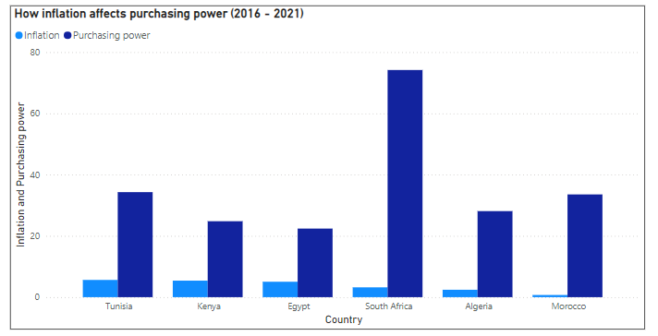**The impact of inflation on purchasing power**

**For 6 countries with complete data for purchasing power and inflation, an analysis was done to determine the correlation between the variables over the years. The resulting correlation coefficient of -0.13 indicates a weak negative correlation.**

**This means that as inflation increased, purchasing power reduced. So with higher inflation, the same amount of money bought fewer goods. Since the correlation is weak, other factors may be influencing purchasing power.**

1. 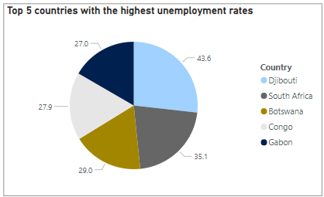**Unemployment**

**In the pie chart displayed, we see the top five countries with high unemployment rates. Djibouti comes first with a 43.6% record. This implies that almost half of its labor force was unemployed within this period.**

**South Africa follows with a 35.1% unemployment rate. Botswana, Congo, and Gabon also have high percentages.**

**Inflation vs Unemployment (for all countries over the 6-year timeline)**

**Overall, there is no strong correlation between inflation and unemployment in the continent. This is evident in the chart displayed below.**

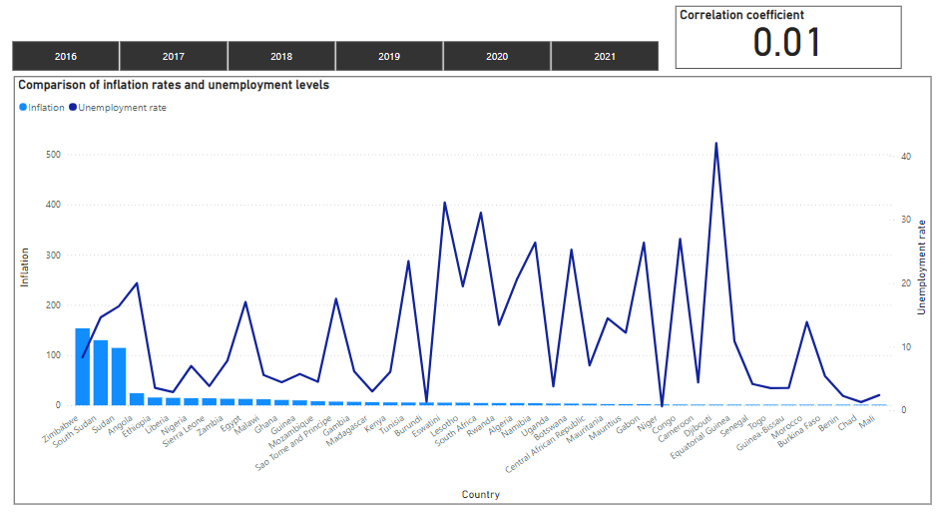

**However, the data reveals that for some countries like Zimbabwe, Mauritius, and Mauritania there is a moderate positive correlation between inflation and unemployment. This is a minute fraction of the 54 African countries.**

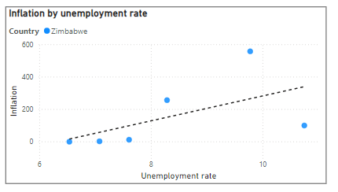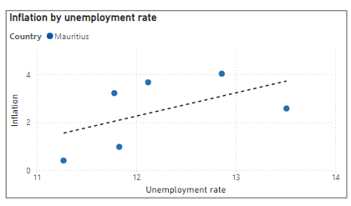**

**In the graphs above we observe that an increase in inflation level also result is high unemployment rates for the countries.**

1. **The relationship between rising cost of living and inflation**

**Rising cost of living means an increase in the cost of essential goods and services which makes it difficult for people to maintain their standard of living with the amount they usually survived on. Inflation is a general contributory factor to this problem although some other actors such as government economic policies or geopolitical events may affect it. Below is a graph that depicts the case for some selected African countries.**

**Morocco and Kenya showed a strong positive correlation between annual inflation rates and average cost of living over the years. The other countries showed a weak to moderate negative correlation. These variations may be attributed to the fact that cost of living is affected by multiple factors and one single variable in isolation may not account for its increase or decrease.**

1. **How rising costs affect business growth**

**To examine the impact of economic changes on business growth, the lending interest rates and foreign direct investments in African countries were evaluated.**

* **Foreign direct investments**

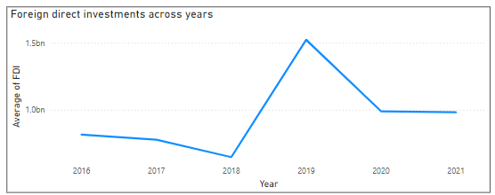**Two notable events here are the significant increase in foreign direct investments between 2018 and 2019 in the continent and the sharp drop from 2019 to 2020.**

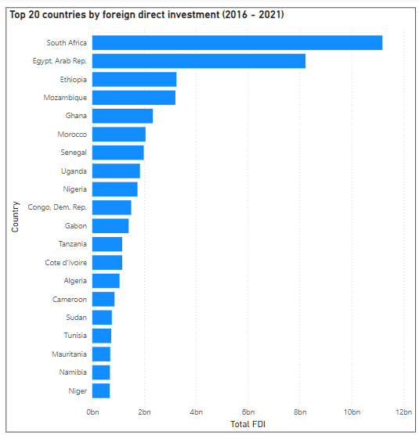

**From these visualizations, it is observed that about half of the countries with high foreign direct investment also recorded relatively low inflation rates. The figure is about the same for countries with low foreign direct investments who also had low inflation rates. Since there is no direct relationship, we will observe other factors like lending interest and annual GDP growth.**

* **Lending interest rates**

**80% of the countries with the highest lending interest rates also fell into the bracket of nations with high inflation rates. The countries are displayed in the following chart. It appears then that high lending interest rates from financial institutions is a measure introduced by the governments of these countries to manage over the top inflation. This may have a temporary negative effect on businesses who struggle to obtain capital.**

* **GDP Annual growth rate**

**The high GDP annual growth rate for countries like Libya, Ethiopia, Guinea, and Rwanda indicates an intentional effort to increase production and sustain the country’s economy. On the other hand, Angola, Chad, and Congo experienced low GDP annual growth rates.**

**Libya has the highest margin of GDP annual growth rate which may be evidence that the government has taken constructive steps to reduce its inflation rate.**

**Recommendations**

1. **The data reveals that almost half of the nations in this continent had high inflation rates. African countries should adopt better monetary policies to keep inflation rates between 2 – 4%.**
2. **Countries like Zimbabwe with very high inflation rates also have high lending interest rate. Although this is a move to counteract inflation, it has a negative present term impact on business confidence and economic development. Policy makers should be proactive to prevent inflation from reaching unmanageable levels.**
3. **Gross domestic product is an indicator of productivity and Libya with the highest GDP annual growth rate reduced its inflation rate by 89% (From 25.85% in 2016 to 2.87% in 2021). Governments and private stakeholders should build more industries to stimulate production. This is a proven way to ensure growth.**
4. **In some countries like Mauritius, Mauritania, and Zimbabwe, rising inflation rates are accompanied by rising unemployment levels. This emphasizes the need to engage the working population for better economic results.**
5. **Kenya and Morrocco demonstrated an interlink between rising cost of living and inflation. Their governments should control the prices of essential goods by introducing effective regulatory measures.**